- This week's data failed to offer the sort of upside surprises in UK inflation and pay growth that would likely be required for the Bank of England's Monetary Policy Committee to change course from its gradual approach to loosening policy.
- Meanwhile, the week's activity data offered mixed signals. Retail sales rebounded strongly after a disappointing December, but the series appears to be suffering from residual seasonality, so we place little weight on the outturn. At the same time, we think GDP growth in Q1 is likely to outperform the results from February's S&P Global survey.
The monetary policy outlook came under scrutiny this week, with the publication of the latest inflation, labour market, and activity data. Though some of these releases prompted some hawkish headlines, there was little in the underlying data to suggest that the Bank of England's Monetary Policy Committee is likely to deviate from the gradual approach to loosening policy it has adopted thus far.
As we highlighted last month, CPI inflation was always likely to rise sharply in January given the upward pressure on services inflation from the imposition of VAT on private school fees and the unwinding of December's temporary weakness in the volatile air fares and accommodation and food sub-categories. In the event, headline inflation jumped to 3%, from 2.5% in December, but a stronger outturn for the food category was the only real surprise.
Services inflation accelerated to 5% from 4.4% in December. But this was 0.2ppts below the BoE's February forecast. And the MPC's preferred measure of underlying services inflation, which excludes indexed categories, volatile components, rents, and holidays, continued to cool (Chart 1).
Chart 1: Services inflation rose sharply in January, but underlying pressures continued to ease
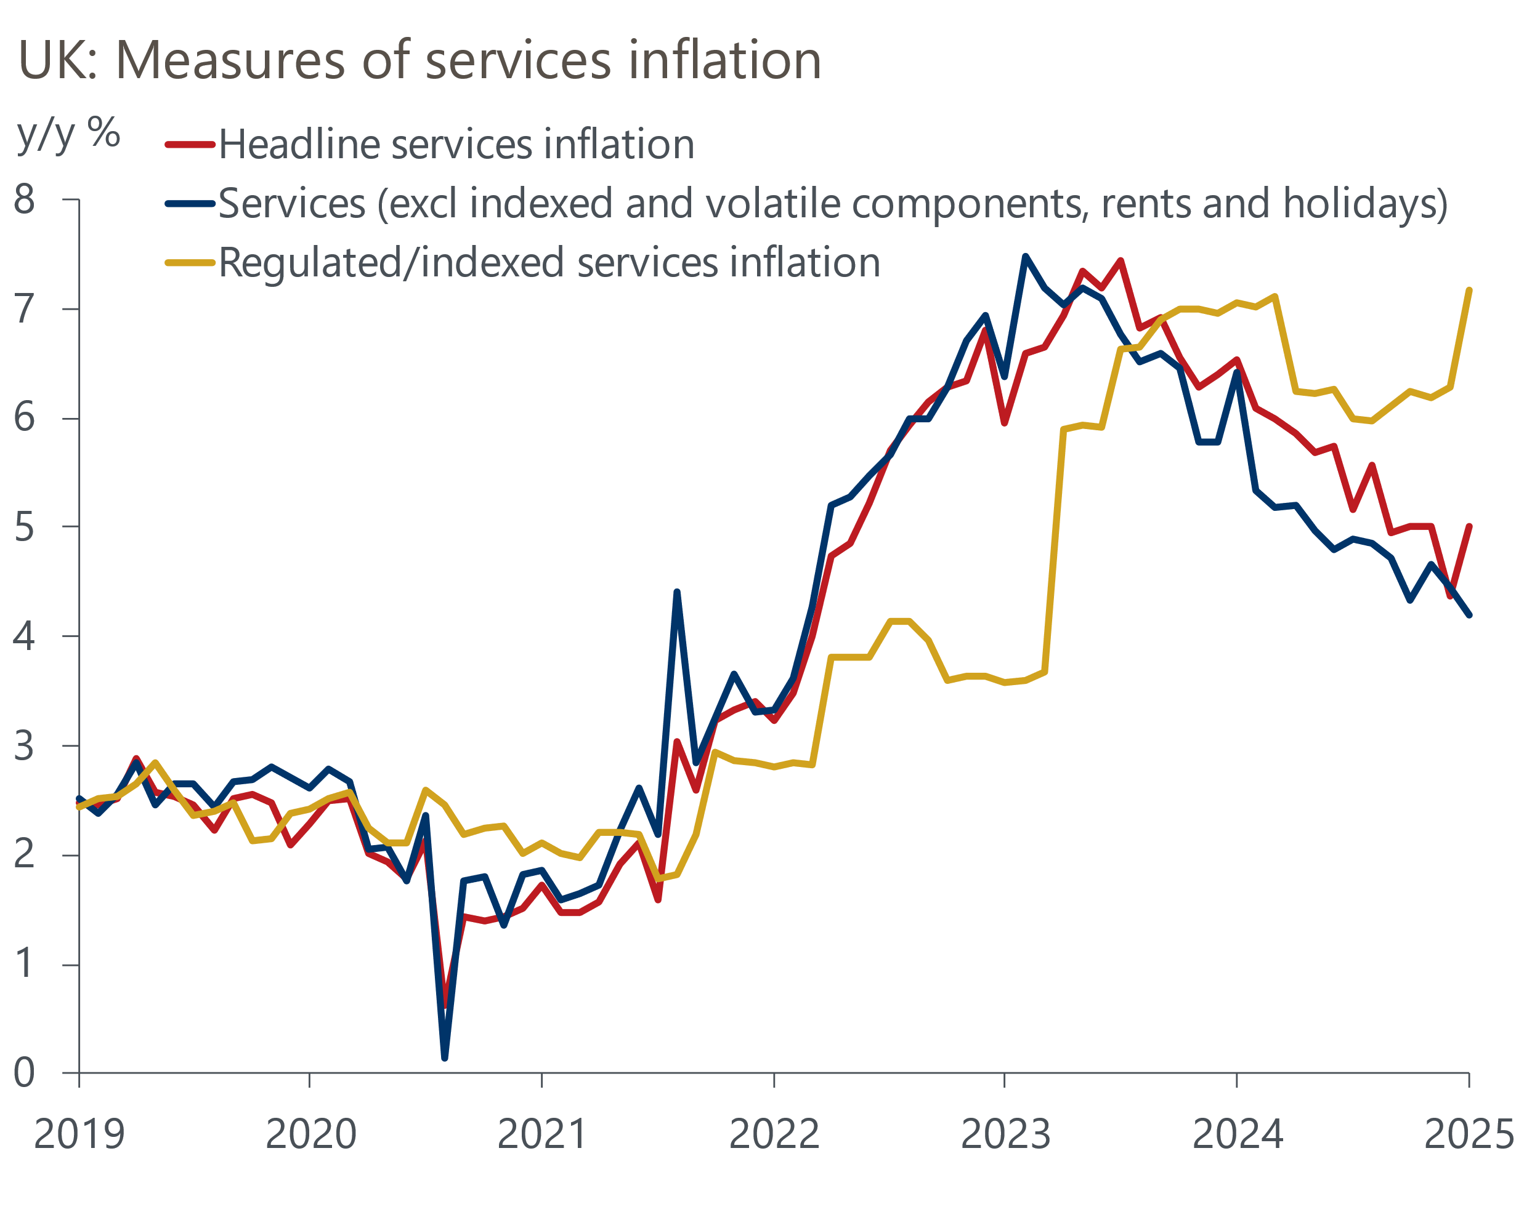
Source: Oxford Economics, Haver Analytics

It was a similar story with the week's pay data. Headline (three-month average of the annual rate) whole economy total pay growth rose to 6% in December, from 5.5% a month earlier. Meanwhile, private sector regular wage growth, the MPC's preferred measure, accelerated to 6.2% from 5.9% in November. However, as was the case with the inflation data, this partly reflected base effects and the outturn came in a touch below the BoE's projections.
The data on labour market quantities was steadier. The unemployment rate was unchanged at 4.4% in the three months to December, though the widely publicised problems with the Office for National Statistics' Labour Force Survey means we place little store on this. But other indicators that are unaffected by these issues also suggested that the labour market flatlined at the turn of the year. Indeed, the long-running decline in vacancies paused in January, while HMRC's count of payrolled employees rose modestly in the same month.
Several MPC members are due to speak at public events next week, including some of the committee's five internal members. But we suspect the latest pay and inflation data is unlikely to have materially shifted their views on the monetary policy outlook for two key reasons. First, the higher outturns this week were well-telegraphed beforehand. And second, they were largely driven by temporary factors that should unwind over the next couple of months.
A feature of recent MPC meetings has been the growing emphasis on concerns about soft output growth and its implications for price pressures in the medium term. This week's activity data didn't provide much clarity on activity. Having disappointed in December, retail sales volumes rebounded sharply in January. However, results showed a very close resemblance with developments a year ago, with food sales plunging in December and rebounding in January, and non-store sales also showing some volatility. So we suspect residual seasonality is likely to have played a major role in January's stronger outturn (Chart 2).
Chart 2: Repeated volatility around the turn of the year points to residual seasonality
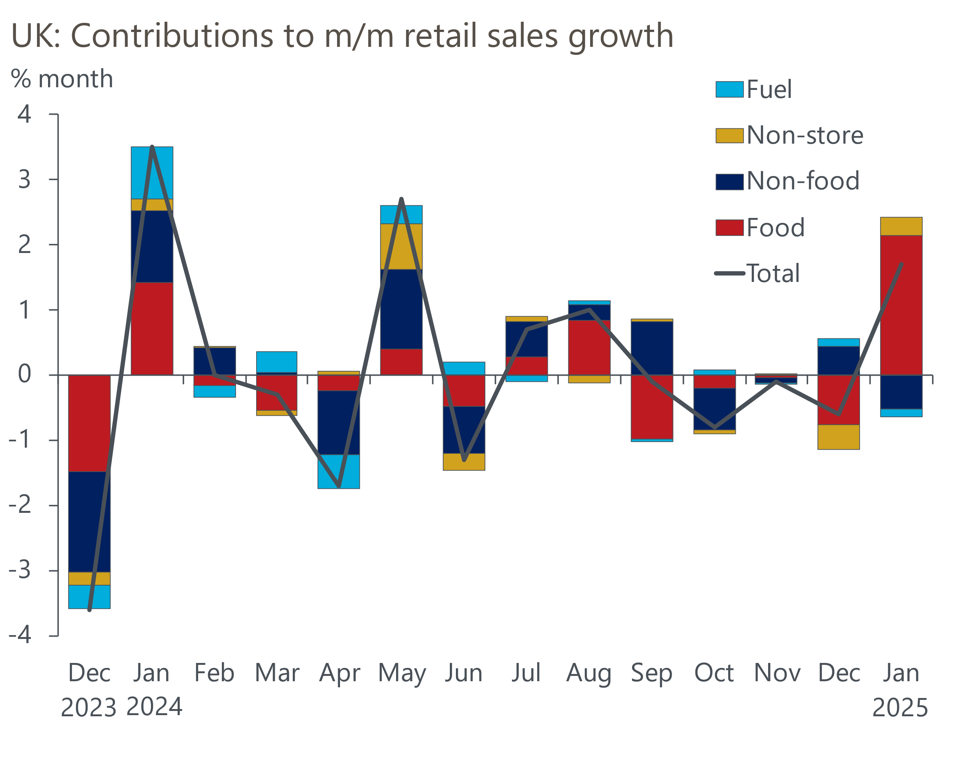
Source: Haver Analytics
We wouldn't read too much into the very modest pace of activity growth signalled by February's flash S&P Global survey either. The composite PMI reading of 50.5 was little changed from January's 50.6. However, the composite PMI has proved a very weak leading indicator of official GDP growth in recent years. Given the strong launchpad offered by December's data, and factoring in January's retail outturn, we think there's a good chance that GDP growth will outperform the results from the S&P Global survey in Q1.
On balance, we saw few genuine signals in this week's data to suggest the MPC is likely to depart from its cautious approach of loosening policy. But while we expect the 'cut-hold' tempo to continue, next week's speeches should offer a better idea about the balance of risks around that forecast.

The week ahead
Next week's only economic data release is Nationwide's measure of house prices.
Table 1: Week ahead calendar
Date | Events | Period | Measure | Unit | Previous | Forecast
Feb 28 | Nationwide house prices | Feb | m/m | % | 0.1 | 0.4
Feb 28 | Nationwide house prices | Feb | y/y | % | 4.0 | 3.6
Source: Oxford Economics

Key forecasts
Table 2: UK forecast overview
(Annual percentage changes unless specified)
 | 2022 | 2023 | 2024 | 2025 | 2026 | 2027
GDP | 4.8 | 0.4 | 0.9 | 1.0 | 1.5 | 1.7
Private consumption | 7.3 | 0.4 | 0.7 | 1.3 | 1.4 | 1.5
Fixed investment | 5.1 | 0.3 | 1.3 | 0.1 | 3.2 | 2.5
Government consumption | 0.6 | 1.0 | 2.0 | 2.4 | 1.6 | 1.6
Exports of goods and services | 12.6 | -3.2 | -2.2 | -1.5 | 1.2 | 1.5
Imports of goods and services | 13.0 | -4.5 | 1.6 | 0.0 | 1.6 | 1.3
Industrial Production | -6.4 | -0.9 | -1.7 | -0.5 | 0.9 | 1.1
Consumer prices | 9.1 | 7.3 | 2.5 | 3.2 | 2.7 | 2.1
Unemployment rate (%) | 3.8 | 4.1 | 4.3 | 4.5 | 4.5 | 4.3
Current a/c balance (% of GDP) | -2.2 | -2.2 | -2.8 | -2.9 | -2.8 | -2.6
Government balance (% of GDP) | 4.1 | 5.2 | 4.9 | 3.1 | 2.8 | 2.1
Central bank policy rate (%, EOP) | 3.50 | 5.25 | 4.75 | 3.75 | 3.00 | 2.50
10yr govt. bond yield (%, EOP) | 3.67 | 3.54 | 4.57 | 4.41 | 3.91 | 3.45
Exchange rate (US$ per £, EOP) | 1.20 | 1.27 | 1.25 | 1.22 | 1.24 | 1.25
Exchange rate (euro per £, EOP) | 1.13 | 1.15 | 1.21 | 1.21 | 1.21 | 1.21
Source: Oxford Economics
Table 3: Quarterly forecasts for the UK
 | 2024 |  |  |  | 2025
 | Q1 | Q2 | Q3 | Q4 | Q1 | Q2 | Q3 | Q4
GDP (% year) | 0.5 | 0.9 | 1.0 | 1.4 | 0.8 | 0.7 | 1.1 | 1.4
CPI inflation (% year) | 3.5 | 2.1 | 2.1 | 2.5 | 2.8 | 3.2 | 3.6 | 3.4
Bank Rate (%, EOP) | 5.25 | 5.25 | 5.00 | 4.75 | 4.50 | 4.25 | 4.00 | 3.75
10yr gilt yield (%, EOP) | 3.95 | 4.17 | 4.00 | 4.57 | 4.57 | 4.57 | 4.50 | 4.41
US$ per £ (EOP) | 1.26 | 1.26 | 1.34 | 1.25 | 1.24 | 1.22 | 1.22 | 1.22
Euro per £ (EOP) | 1.17 | 1.18 | 1.20 | 1.21 | 1.20 | 1.21 | 1.21 | 1.21
Source: Oxford Economics

Latest Country Economic Forecast:
February 20, 2025

Recent publications

Data Insights
PMI too pessimistic on Q1 growth performance
Retail sales soared in January, but seasonality likely played a role
Government borrowing is running well above the OBR's forecast
January's hotter inflation print reflects erratic and one-off factors
Labour market data confirm challenge facing Bank of England

Research Briefings
What the rise in NICs means for the labour market
Two fiscal wild cards in the Spring Forecast
The UK's fiscal adjustment is at risk of failure
MPC cuts rates, but growth-inflation dynamic is worsening
MPC preview – Maintaining the dovish message

Contacts

Oxford Economics' UK team
- Andrew Goodwin - Chief UK Economist - agoodwin@oxfordeconomics.com
- Edward Allenby - UK Economist - eallenby@oxfordeconomics.com

